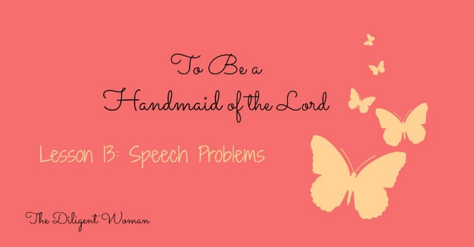
Lesson 13
Speech Problems
“Sticks and stones may break my bones, but words can never hurt me.”
Have you ever said that? Why did you say it? Probably to someone who has said something not so nice to you to let them know you’re not fazed by what they said. The truth is words do hurt, but they also can do good.
“Who sharpen their tongue like a sword, and bend their bows to shoot their arrows – bitter words.” Psalm 64:3
“Pleasant words are like a honeycomb, Sweetness to the soul and health to the bones.” Proverb 16:24
This is another choice for you – how you USE your words. Let’s go looking for what God has to say about SPEECH PROBLEMS.

Read James 3:5-18.
1. James taught that what we say doesn’t harm anything or anyone. TRUE or FALSE

2. Read Matthew 15:11-18. (We’ve read this before.) How does this scripture go along with the one in James?

3. According to John 8:44, who is the father of lying?
4. Read Genesis 3:1-4. How many words did it take to make Satan’s statement a lie?

5. Tell how lying played a part in the story of Jacob and Esau from when we studied Rebekah.

6. Cain’s murder of Abel left him open to do what in Genesis 4:9?

Read Acts 5:1-11.
7. What lie did Ananias and Sapphira tell?

8. Were they trying to do a good thing?

9. Did that make lying about it all right?

10. Read Proverb 6:16-19. Seven things the Lord hates – how many are done by the tongue (speech)?

11. In Proverbs 10:18-21 there is a series of things about words. Use the verses to answer the following:
Hiding hatred is __________.
Spreading slander is __________. (Slander is a spoken false statement that damages the reputation.)
Talking a lot makes opportunity for ____________.
Being quiet is _______.
The value of words from the righteous person is as ____________.
The value of the heart (thoughts) of the wicked person is ____________.
Righteous words are a benefit to _________ while fools die for lack of _____________.

I think we understand that lying is not good. Let’s see about GOSSIP.
12. Write Proverb 11:13 here.

13. What is “gossip” or “tale bearing”?

14. Is it normal that people like to hear the things that are said in gossip? (Prov. 18:8)

15. Does our liking to listen to it make it RIGHT to listen?

16. What does stopping gossip do? (Prov. 26:20)

17. Proverb 20:19 repeats the idea that “a talebearer reveals secrets” and adds a command. How would flattery and gossip go together?

18. According to 1Timothy 5:13, 14, how can a young widow avoid being a gossip and busybody? (This doesn’t only apply to young widows. )

19. Gossip is not a very serious sin compared to something like murder. (Rom.1:28-32) TRUE or FALSE

20. What is “flattery”?

21. What company does flattering speech keep in Psalm 5:8, 9?

22. Read Psalm 12:1-4; Prov. 26:28; and 1 Thess. 2:5. Flattery is a valid way to build someone up. TRUE or FALSE

We’ve covered talking about OTHER people, what about talking about OURSELVES?

23. Read Proverb 25:14. Explain this proverb in your own words.

24. It is always best that you let others know about your own accomplishments. (Prov.27:2)
TRUE or FALSE

Are you noticing that WORDS can do harm? I often tell my daughters to “use their words”. Words are POWERFUL. We MUST be careful with them. Words reveal the hidden person of the heart – whether righteous or not. CHOOSE your words carefully. Speak to others the way you’d like to be spoken to.
“For all the law is fulfilled in one word, even in this: ‘You shall love your neighbor as yourself.’ But if you bite and devour one another, beware lest you be consumed by one another.” Galatians 5:14-15
Some BENEFITS of SOUND words.
Declares righteousness, promotes health, is established forever – Proverbs 12:17-19
Turns away wrath – Proverb 15:1
Is a tree of LIFE – Proverb 15:4

Conclusion:
The cure for an out of control tongue:
Confession and prayer – James 5:16
THINK BEFORE YOU SPEAK!
Treat others the way you want to be treated – Matthew 7:12
Fill your mind with GOOD THINGS – Philippians 4:8
Use your words to BENEFIT OTHERS rather than yourself – Rom. 14:19; 1 Thess. 5:11

In Your Bible –
Proverb 8:13 Proverb 10:32 Proverb 29:5
Proverb 12:22 Proverb 13:3, 5 Proverb 21:9, 19
Proverb 28:23 Proverb 26:22 Proverb 16:28 Proverb 25:15

